**Nick Kamarianakis - Materials**

**Question**: What material to use for the body of the bike and to house its electrical components?

**Engineering Principles:** Durability

Strength-Weight Ratio

Cost Effective

**Durability:** -Driver must feel safe

-Withstand wear and tear of regular bike

-Withstand harsh and extreme weather conditions (eg. salt on road)

**Strength-Weight:**

-“You are the one pedaling uphill”

-lighter material causes less use of battery

-Must be safe and impact resistant

**Cost Effective:**

-needs to be an affordable method of transportation

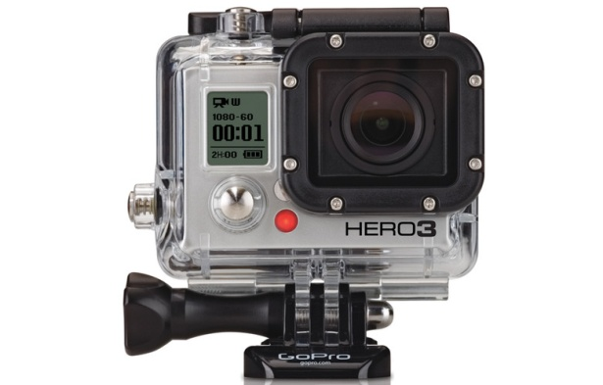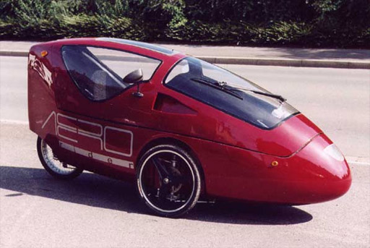

**References:**

Aerorider. (1999). *Ultra-light electric hybrid tricycle vehicle* [Online]. Available: http://www.aerorider.com/en/aerorider.html

P. Gilham. (2011). *Sensigraphics: Polyester vs. Polycarbonate Materials*[Online]. Available: http://sensigraphics.blogspot.ca/2010/01/polyester-vs-polycarbonate-materials.html